Complaints Form
Everyone has the right to complain if they are unhappy
- Personal details – Please leave blank if you would like to remain anonymous
Name:
Phone number:
Address:

Email address:
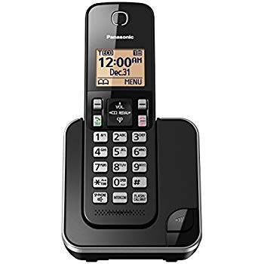
Preferred Contact Method: Telephone
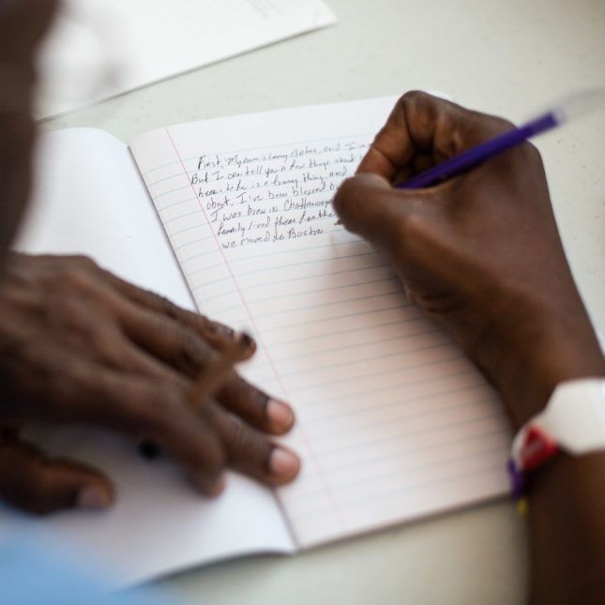
Letter

Email

Have you had a chat with staff about what you are unhappy about?
Yes No

Do you need help from staff or an advocate to make a complaint?
Yes No

Do you need help to make a complaint to the NDIS Quality and Safeguards Commission?
Yes No

What is wrong?

How can we fix it?

- Acknowledgement
Everything I have said is the truth.
Signature Date

____________________________________ (name) helped me complete this form.

